Create Backup of Case Entity

* 1. Navigate to **Settings** | **Customization** | **Solutions**
  2. Click on **New**
     1. 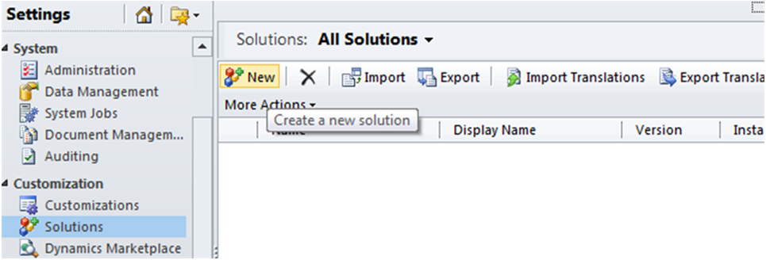
     2. Figure 1
     3. New solution
  3. Enter the following:

|  |  |
| --- | --- |
| Field Name | Value |
| Display Name | ‘Case Entity Backup’ |
| Publisher | Default Publisher |
| Version | ‘1.0.0.0’ |

* 1. Click **Save.**
  2. Click on Components
  3. Click **Add Existing**, and choose **Entity**.

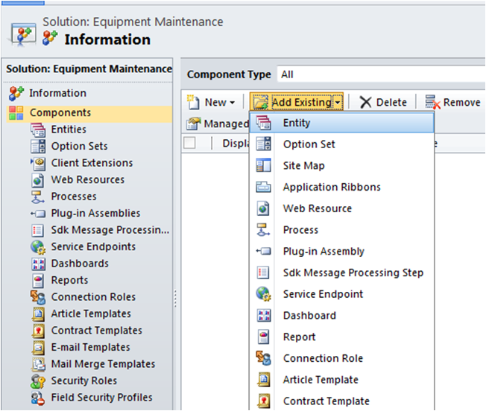

* 1. Locate and **select** the *Case* entity and proceed as show in two images below.

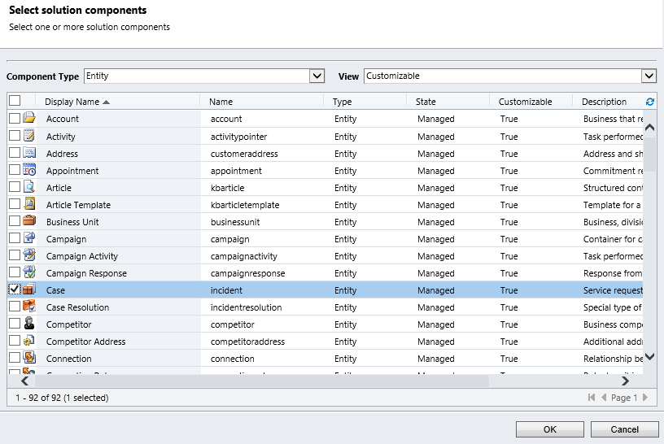

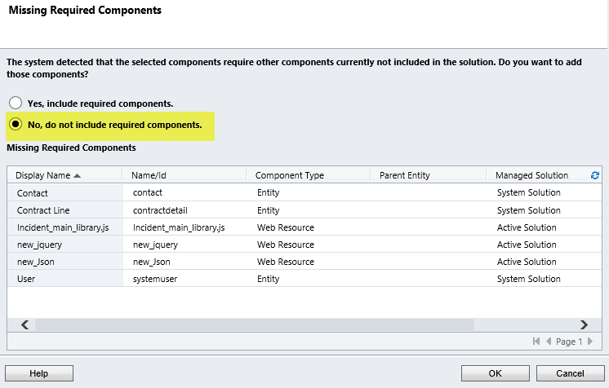

* 1. The *Case* entity is now listed under Entities on the left navigation.

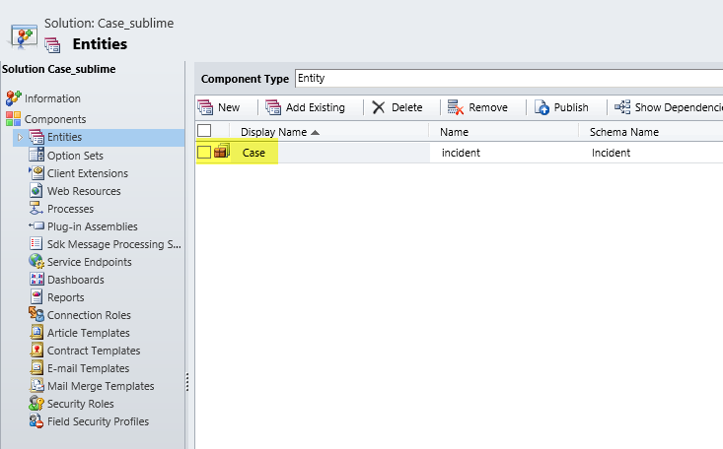

* 1. Export & Save the solution as shown below

